Shermin Thomas

Professor Marissa Dubois

Major assignment 4: The Research Article

November 28, 2021

**Introduction**

Climate change has been ranked one of the most ubiquitous issues in the world. Changes in typical degrees of warmth, cold, rain, and wind are known as environmental or climate change. The climate started changing a long time ago due to human activities. Scientist and other environmental activists’ states that industrial activities play a major role in this climate change, the industrial activities that our advanced civilization relies on having raised environmental carbon dioxide level from 280 parts per million about 417 parts for every million over the most recent 151 years. This climate change has a significant impact on ecosystems and organisms. According to WWF due to climate change up to half of plant and animal species in the world’s most naturally rich areas, such as the Amazon and the Galapagos could confront local extinction. Up to 90% of creatures of land and water, 86% of birds, and 80% of mammals might turn out to be locally wiped out in the Miombo Woodlands in South Africa. Studies say that Amazon Forest could lose 69% of its plant species. Nowadays people are getting concerned about this issue and there are many ongoing awareness programs and organizations that work around the world for the climate change issue. “Discourse community is seen as a complex collection of individuals who share genres, language, value, concepts and” “way of being” (Geertz,1983) (Wardle and Downs, 2020) (562). Starting in the early 2000s social media has had a strong presence in modern society. These days almost everyone has access to a profile on one social media website or another and they are using it to make changes where they see that it needs to be made. Using hashtags in a post is one of the popular methods used to ensure that our messages reach a border extensive. Environmental brands have begun campaigning to bring awareness to particular topics: #FridaysForFuture is one of them. In August 2018 a 15-year-old girl Greta and other environmental activists protested in front of the Swedish parliament for three weeks, they were attempting to bring issues to light against the Swedish government’s absence of activity against climate change and the protest went viral through Twitter and Instagram. This movements shows that through social media people can make a positive difference in the world. Social media is an absolute good tool, which can use for environmental activism, people can share awareness posts through social medias. My research question is, how does sharing posts, flyers, advertisements, and posters build a vital awareness of climate issues among the people, and does it motivate an ordinary person to take a step to reduce the effect of climate change?

**Literature Review**

I collected six sources for the research. All my sources relate to each other one way or another way. Among the six sources two of them give background information about climate change, it talks about how the industrial era led to the changes in the weather pattern and how it affected the ecosystem. Human activities are the major reason for climate change, climate change has resulted in the devastation of natural habitats and the decline of various sectors. Climate change not only affects the life of living organisms but can also affect the important sectors of society. According to research lead by U.S research Global program severe climate changes brought a devastative change in the agriculture, fisheries, and poultry sector. These sectors depend on climate and weather for their production. Sudden changes in the climate have changed the nature of the soil, amount of rain, and increase in the sea level and temperature, which led to the decline of these industries and the life of the people who depend on these sectors for their live hood are in crisis. Because of the climate change countries like Syria and other deserted countries are experiencing a once-in-a-century drought which drives people into poverty. The sources also mention the steps taken by the US government for the excessive changes in the weather pattern.

The rest of the four sources talks about the role played by social media to make people think about climate change. Since the beginning of the industrial age, there have been concerns about the increase in the average global temperature, which is primarily caused by human action. This unexpected change in the weather pattern affected millions of lives, causing devastating natural disasters including wildfires, droughts, floods, mass migration, which will lead to regions of the world becoming uninhabitable. Nowadays social media are used as one of the effective mediums of communication. Climate activists have used nearly every popular social media platform to advocate for their cause. Twitter and Facebook are the most popular social media used for this kind of awareness and protests. Apart from the environmental-related groups and pages, nowadays influencers from different sectors also share awareness posts and videos about climate change. “The concept of global warming was created by and for the Chinese in order to make U.S manufacturing competitive”, this is a tweet shared by Donald Trump on Twitter, it was retweeted nearly a thousand times and got hundreds of comments by both supporters and critics. This is one of the top five tweet regarding climate change because of its popularity. In 2017 NatGeo shared an image on Instagram of a starving polar bear that highlighted the effect of climate change on wildlife. Due to the absence of ice and snow, this polar bear is in an extremely emaciated state and will likely not live much longer. This post has been liked roughly 1.7 million times on Instagram. In August 2018 a 15-year-old girl Greta and other environmental activists protested in front of the Swedish parliament for three weeks, they were attempting to bring issues to light against the Swedish government’s absence of activity against climate change and the protest went viral through Twitter and Instagram. This movement shows that through social media people can make a positive difference in the world. Social media is an absolute good tool, which can use for environmental activism, people can share awareness posts through social media.

The article “Climate Change” owned by National Geographic society and the article “Fact sheet: Administration Announces New Initiative to Increase Solar Access for All Americans” owned by office of energy efficiency and renewable energy, highlights background information’s, causes and modern solution for the climate change. Throughout the earth’s history, the climate has consistently changed. While occurring normally, this is a slow process that took hundreds of years but the human-impacted environmental change that is going on now is occurring at a lot quicker rate. The scientists of NASA and others around the world declared the presence of greenhouse gases in the atmosphere as a reason for the drastic change in the climate. This change in the climate has resulted in the devastation of natural habitats and the decline of various sectors. Climate change might make weather patterns to be less predictable. These unexpected weather patterns can make it hard to keep up with and develop crops in the regions that rely on farming because expected temperature and rainfall levels can no longer be relied on. This drastic climate change also resulted in more frequent and intense typhoons, floods, downpours, and winter storms. The article “Administration Announces New Initiative to Increase Solar Access for All Americans” focus on the action plan proposed by President Obama in June 2013 to protect the United States from the impact of climate change. This action plan had three main objectives: 1. Cut carbon pollution in America – According to President Obama’s action plan, carbon pollution in the United States can be reduced by cutting the emission of carbon from powerplant and by promoting renewable energy. The fuel economy standards were increased, the estimates show that “the greenhouse gas emission will be reduced by approximately 270 million metric tons and save 530 million barrels of oil” (president action plan 8). 2. Prepare the U.S. for the impact of Climate change- Initiative include. “Building stronger and safer infrastructure and communities, conserving land and water and promoting Insurance leadership for climate safety” (President’s action plan). 3. Lead international efforts to combat Global climate change and prepare for its impact- The U.S. formed partners with countries to develop new transformational low carbon technologies and to reduce the emission of greenhouse gages. Also, the negotiation of global free trade in environmental goods and services reduced tariffs for clean energy technologies. (President action plan).

The articles “Can Social Media Save Our Planet from Climate Change?” (Whiting, Tabitha), “When Social Media Meets Climate Change.” (Chetwynd, Josh), “Use Social Media to Combat Climate Change Awareness” (Limited, Jamaica Observer), and “#ClimateChange Social Media Movement” (Faramarzi, Sachdev and Palmer) highlights how social media is used as a tool to make people aware about climate change. Starting in the early 2000s social media has had a strong presence in modern society, social media is used as one of the effective mediums of communication. Now a days social media is not only used to share our pictures or videos, but it is also widely used to make awareness about many social issues, there are many pages and groups in social media where people share their thoughts and ideas about a particular topic which remove boundaries of time and distance, bringing together similar minded people. Climate activists have used nearly every popular social media platform to advocate for their cause. Twitter and Facebook are the most popular social media used for this kind of awareness and protests. For instance, Earth League International, World Conservation Congress, Stand Earth, COP26 and UN climate change are some of the pages we can find on Instagram which deals with environmental issues, they share awareness pictures, posts, and articles about the issue. When it comes to environmental issues companies recognize the value of social media. According to Grist.com, “In the four weeks leading up to the 2018 midterm elections, the five oil majors spent 2 million dollars on targeted ads on Facebook and Instagram aimed at eroding support environmental initiatives.” Popularity gives power on social media sometimes in 2016 when Leonardo DiCaprio mentioned climate change in his Oscar acceptance speech, it led a spike in global warming discussion on Twitter and as DiCaprio continued to speak on the subject, he retained a role as a major influencer on that platform. Social media plays a major role when organizing things, when kids in 112 different countries planned to coordinate a school walkout to bring attention to climate change, social media was essential, students used social media to reach out to other people.

**Methods**

One cannot argue that social media has overwhelmed the world by allowing similar-minded people to connect and share their experiences with the world. These days social media is used as a key tool to organize protests and awareness about the social issues, changes that happening in the ecosystem, and going to happen in the future due to climate change is one of the hot topics discussed all over social media. NatGeo, Nasa climate change, Earth League International, World Conservation Congress, Stand Earth, COP26, and UN Climate Change are some of the pages on Instagram which deal with environmental issues, they share posts on an everyday basis to make us aware of how to save the planet. These pages not only share images and videos but also organize protests, movements, and conduct fundraising programs to support earth-saving projects and wildlife. Apart from these environment-related pages, there are also influencers and climate activists who use their power to raise awareness of climate change, Leonardo DiCaprio is one of the most prominent climate activists today, he established the Leonardo DiCaprio Foundation which supports wildlife projects around the world and an 18-year-old girl Greta, who paved the way to start an ongoing social media protest which helped thousands of people around the world to start thinking about our plant. Referring to their social media pages and collecting the posts shared by them is the way I collect my primary data. Also, analyzing the reaction of people on these posts especially going through the comment section and how many people liked the posts.

**Data/Analysis**

My research question is, how does sharing posts, flyers, advertisements, and posters build a vital awareness of climate issues among the people, and does it motivate an ordinary person to take step to reduce the effect of climate change. To collect my primary data, I gathered some screenshots of the posts shared on different social media pages which talk about climate change, this data helped to build support for my research question. The pictures I mentioned above are some of the posts shared and liked by thousands of people. When I go through the posts, I understood that they played a major role among the people to make them aware of the climate change issue. When we go through the posts, we can see that all the posts are about the issue of climate change, the first three posts are about the after effect of climate change, especially how it is affecting our ecosystem and its inhabitants. The last post is an awareness post shared by one of the top influencers, the post talks about that climate change is real and it’s time to act, under the post DiCaprio also mentioned some of the ways we can begin to start protecting our planet and to join them. Social media is considered a great tool for effective communication among people, it helps to connect people worldwide, when Greta Thunberg started a protest many people from around the world got inspired by the post shared by millions of people around the world through different social media. There are hundreds of pages and groups in social media related to the environment and our planet and they share posts and videos on an everyday basis, but how many of us care about the posts, majority of us do not even try to read the post, we just scroll away to some fun videos or pictures, some people just look through the post and they will post comments and share it to their story, but do they take any initiative to reduce the climate change effect, this is the question come to my mind when I go through all these data, because I do follow some of these popular pages, but I never put any effort to read them or take a step to save our planet.

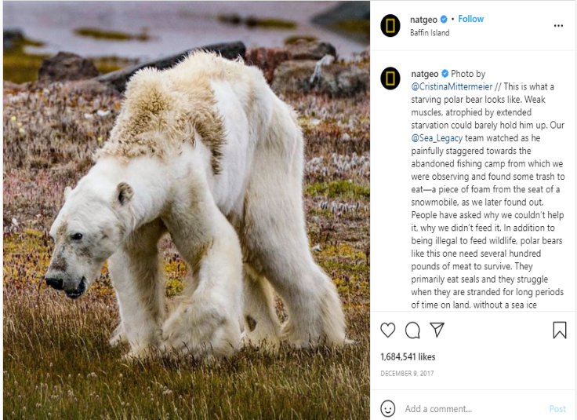

In 2017 NatGeo shared an image of a starving polar bear which highlighted the effect of climate change on wildlife. Due to the absence of ice and snow, this polar bear is in an extremely emaciated state and will likely not live much longer. This post has been liked roughly 1.7 million times on Instagram, but a like or share on Instagram won’t be helpful to save this animal from starving or the loss of it inhabit, we need to take the right measure to save this animal, so I am looking into do people care about these posts when they see it on social media or they just like and not even try to read and scroll to next post. It never matters how many people liked or shared it, until people take steps to eradicate climate change.

Apart from making connections with people, social media is widely used as a key tool to start awareness or protest about issues. Through sharing posts and posting stories social media help people to understand about some on-going issues in the world. Usually, it seems that people are not interested in reading news or watching the news on TV, so social media is considered the easiest way to reach people around the world. The picture posted above is a post viewed, liked, and shared by thousands of people, what if instead of posting on Instagram this picture shared through a new paper or any other news article, it won’t get much attention because a study proves that about 70% of people use social media every day, on the other hand only 29% of people read a newspaper on an everyday basis, all these findings prove that social media is a great tool when something needs real attention.

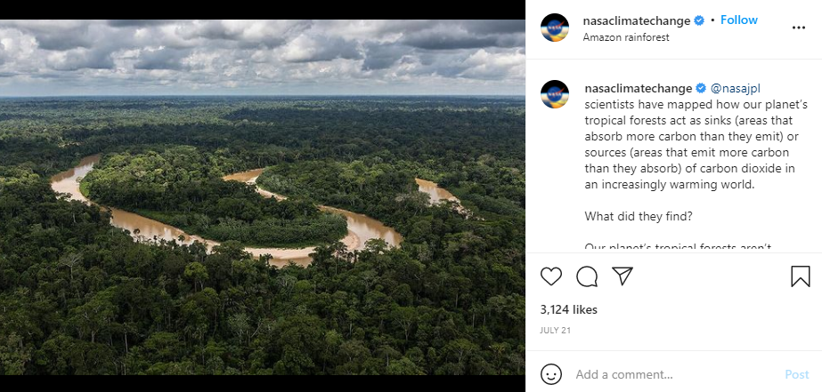

This image is a post shared by nasaclimatechange, the post open our eyes to the current situation of Amazon Forest, a study proves that a part of the Amazon rainforest is now emitting more carbon dioxide than they absorb, raising fears of the potentially devastating impact on its fragile ecosystem and a further worsening of the climate crisis, according to a new study. Amazon is one of the largest rainforests and home to countless species of fauna and flora. But in the past 40 to 50 years, the rainforest has undergone tremendous and disruptive change due to human impact. It has lost 17% of its forest, most of which has been turned into agricultural land for farming and livestock. This led to the rise of temperature and water evaporation to drop, meaning less rainfall.

It is not easy for us to understand what is happening in a place where it is hard to reach and see it ourselves, but social media solved that issue, the picture mentioned above is a post shared by an Instagram page, nasaclimatechange. It shows the current face of the Amazon rainforest which is considered as the “Lungs of the Earth”. Through sharing the picture on social media scientists make sure that everyone should be aware of what is happening around the world due to climate change and how it’s affecting our ecosystem, after posting this picture the comment section was filled with people mentioning how humans are going to wipe out this planet and how should the government give priority to climate change and encourage people to take steps to eradicate the effects of climate change. So, I think through sharing this one post can make a difference even a small difference can pave way for a big change.

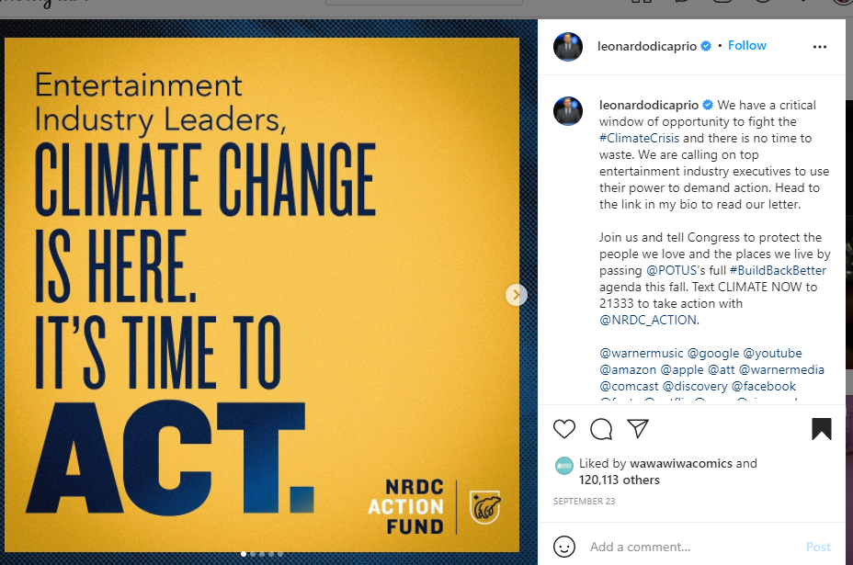

This screen shot is a post shared by the actor and the current environmental activist Leonardo DiCaprio, the post says “Entertainment Industry leaders, climate change is here it’s time to act”. People are tending to follow actors, and other influential people on social media, their stories and posts have thousands of viewers than an ordinary person. Around 50m people follow Leonardo DiCaprio on Instagram and if he shares a post not less than 10m people will read and share his post, but think about if an ordinary person shares a post about climate change, it won’t get that much attention. When Leonardo DiCaprio shared a post about climate change his followers will repost them, but among how many people care about climate change or how many of them want to make the world a better place.

**Discussion/conclusion**

From all the articles and posts I collected to find an answer for my research question, I find that social media is a powerful tool for communication. There are lots of campaigns and movements started in social media which created a big change in society. Social media is also used in coordinating rescue and relief operations after climate change-related disasters and to organize movements and campaigns about climate change. David Attenborough’s Blue Planet 2 is a great illustration of how social media can be utilized to reinforce and spread current facts of climate change. Blue Planet 2 focused on our oceans, which speaks about the huge issue of ocean plastic waste. Blue Planet 2 was broadcast on television in late 2017, but the conversation about the series continues social media to this day especially on Twitter. Ultimately it seems that social media can be an incredibly effective tool for communicating about climate change. That’s especially true if we’re focusing on community building and bringing like-minded people together. Social media is also used in coordinating rescue and relief operations after climate change-related disasters and to organize movements and campaigns about climate change. Online protests like #MeToo and #BreakFreeFromPlastc, powered by social media, have grown from powerful online campaigns to real-world policy change. A group called LAD bible created a social media campaign to engage the youth audience, to shift their thinking around climate change, and turn apathy into action. This group used Facebook live to depict the amount of carbon emission released in real-time instigating discussion within the community. This Facebook live resulted in 45 million reach and 8 million engagements, which clearly shows that social media can be used as a tool for awareness about social issues.

**Works Cited**

* Chetwynd, Josh. “When Social Media Meets Climate Change.” *Medium*, The Public Interest Network, 19 Apr. 2019, https://medium.com/the-public-interest-network/when-social-media-meets-climate-change-5aec5326e21f. Accessed date October 6, 2021
* “#ClimateChange Social Media Movement.” *#MoveMe*, 22 Apr. 2000, <https://moveme.berkeley.edu/project/climate-change/> Accessed date October 6, 2021.
* DiCaprio, Leonardo (@leonardodicarpio), we have a critical window, Instagram, September 23, www.instagram.com/p/CULA5_opeMw/.
* “Discourse Communities and Communities of Practice.” *Writing about Writing*, by Elizabeth Wardle, Bedford/St. Martin's, Macmillan Learning, 2020.
* Everyday climate change (@everydayclimatechange). Photo of deforestation. Instagram, photographed by rainforestcx, November 13 2020, https://www.instagram.com/everydayclimatechange/.
* Faramarzi, Sachdev and Palmer. “#ClimateChange Social Media Movement.” *#MoveMe*, 22 Apr. 2000, https://moveme.berkeley.edu/project/climate-change/#social-media-presence.
* Limited, Jamaica Observer. “Use Social Media to Combat Climate Change Awareness.” *Jamaica Observer*, https://www.jamaicaobserver.com/opinion/use-social-media-to-combat-climate-change-awareness_147648?profile=1096. Accessed date October 6, 2021.
* Nasa climate change (@nasaclimatechange). Photo of tropical forest sinking. Instagram, photographed by nasajpl, July 21, https://www.instagram.com/nasaclimatechange/.
* National Geographic (@NatGeo). Photo of starving polar bear. Instagram, photographed by Cristina Mittermeier, December 10 2017, https://www.instagram.com/p/BceylHujELW/.
* National Geographic Society. “Climate Change.” *National Geographic Society*, 27 Mar. 2019, https://www.nationalgeographic.org/encyclopedia/climate-change/. Accessed date October 6, 2021
* “Social Media Essay: Benefits and Drawbacks of Social Networking Sites: Blog.” *Whatagraph*, https://whatagraph.com/blog/articles/social-media-essay.
* “The Causes of Climate Change.” NASA, NASA, 30 September 2019, <https://climate.nasa.gov/causes/>
* The National Aeronautics and Space Administration. “The Causes of Climate Change.” *NASA*, NASA, 30 Aug. 2021, <https://climate.nasa.gov/causes/> Accessed date October 5, 2021.
* “What Genres Are.” *Writing about Writing*, by Elizabeth Wardle, Bedford/St. Martin's, Macmillan Learning, 2020, pp. 34–35.
* Whiting, Tabitha. “Can Social Media Save Our Planet from Climate Change?” *Medium*, The Startup, 25 June 2019, [https://medium.com/swlh/can-social-media-save-our-planet-from-climate-change-b3b1e81f64f7.](https://medium.com/swlh/can-social-media-save-our-planet-from-climate-change-b3b1e81f64f7.%20%20) Accessed October 6, 2021.