Shermin Thomas

11/4/2021

Primary data collection

Climate change has been ranked one of the most ubiquitous issues in the world. The weather conditions prevailing in an area over a long period is the climate of that region. Decades ago, a change in the climate pattern was identified globally. This climate change has resulted in the devastation of natural habitats and the decline of various sectors. Nowadays people are very concerned about this issue and there are many ongoing awareness programs and organizations that work around the world for the climate change issue. Along with that, there are many pages and groups in social media which deal with environmental issues, they share posts on an everyday basis to make us aware of how to save the planet. My research question is, how does sharing posts, flyers, advertisements, and posters build a vital awareness of climate issues among the people, and does it motivate an ordinary person to take a step to reduce the effect of climate change.

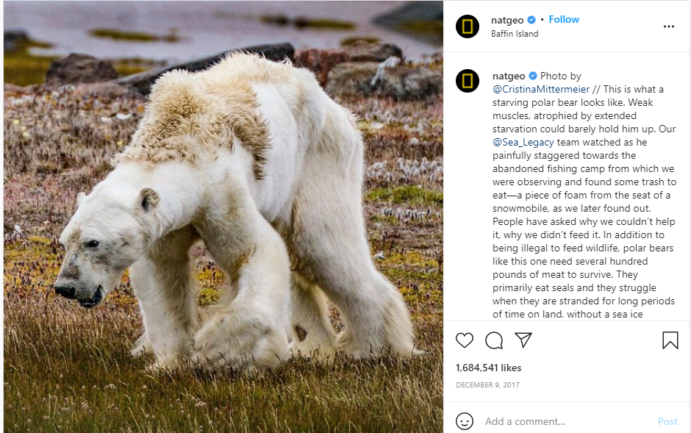 The screenshots I mentioned above are some of the posts shared on Instagram by different influential pages and influencers. The first image is a post shared by NatGeo in 2017 of a starving polar bear that highlighted the effect of climate change on wildlife. Due to the absence of ice and snow, this polar bear is in an extremely emaciated state and will likely not live much longer. This post has been liked roughly 1.7 million times on Instagram, but a like or share on Instagram won’t be helpful to save this animal from starving or the loss of it inhabit, we need to take the right measure to save this animal, so I am looking into do people care about these posts when they see it on social media or they just like and not even try to read and scroll to next post. It never matters how many people liked or shared it, until people take steps to eradicate climate change.

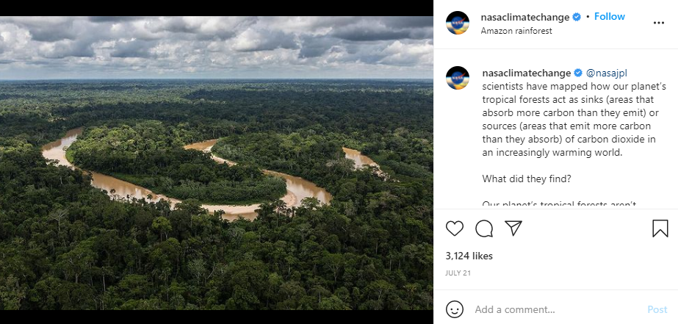

The second image is a post shared by nasaclimatechange, the post open our eyes to the current situation of Amazon Forest, a study proves that a part of the Amazon rainforest is now emitting more carbon dioxide than they absorb, raising fears of the potentially devastating impact on its fragile ecosystem and a further worsening of the climate crisis, according to a new study. Amazon is one of the largest rainforests and home to countless species of fauna and flora. But in the past 40 to 50 years, the rainforest has undergone tremendous and disruptive change due to human impact. It has lost 17% of its forest, most of which has been turned into agricultural land for farming and livestock. This led to the rise of temperature and water evaporation to drop, meaning less rainfall.

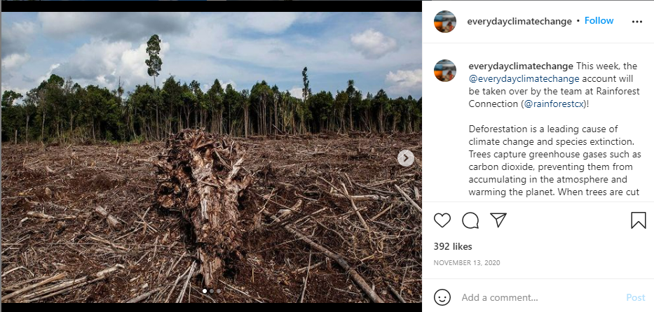

The third image is a post shared by the Instagram page, everydayclimatechange. The post portraits deforestation, which is the leading cause of climate change and the extinction of species. The image is shared with a caption explaining the aftermath of deforestation and the major role of trees to balance the ecosystem. Everydayclimatechange is a social media page managed by a diverse group of photographers from 6 continents, they share pictures, posters, and videos related to climate change which make people aware that climate change is real and we have to take steps to reduce the effect of climate change.

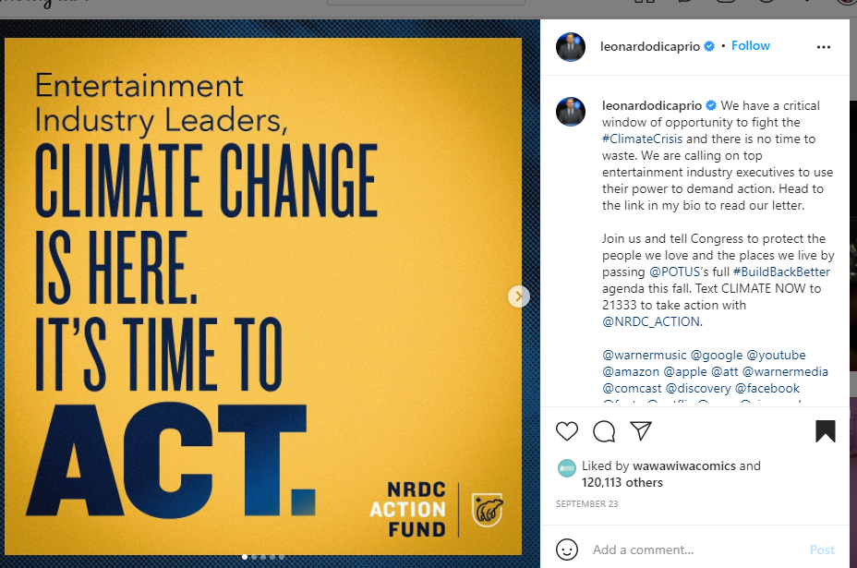

The fourth image is a post shared by the actor and the current environmental activist Leonardo DiCaprio, the post says “Entertainment Industry leaders, climate change is here its time to act”. People are tending to follow actors, and other influential people on social media, their stories and posts have thousands of viewers than an ordinary person. Around 50m people follow Leonardo DiCaprio on Instagram and if he shares a post not less than 10m people will read and share his post, but think about if an ordinary person shares a post about climate change, it won’t get that much attention. When Leonardo DiCaprio shared a post about climate change his followers will repost them, but among how many people care about climate change or how many of them want to make the world a better place.