Shermin Thomas

Professor Marissa Dubois

Research Article Draft

November 16, 2021

**Introduction**

Changes in typical degrees of warmth, cold, rain, and wind are known as environmental or climate change. The climate started changing a long time ago due to human activities. Scientist and other environmental activists’ states that industrial activities play a major role in this climate change, the industrial activities that our advanced civilization relies on having raised environmental carbon dioxide level from 280 parts per million about 417 parts for every million over the most recent 151 years. This climate change has a significant impact on ecosystems and organisms. According to WWF due to climate change up to half of plant and animal species in the world’s most naturally rich areas, such as the Amazon and the Galapagos could confront local extinction. Up to 90% of creatures of land and water, 86% of birds, and 80% of mammals might turn out to be locally wiped out in the Miombo Woodlands in South Africa. Studies say that Amazon Forest could lose 69% of its plant species. Nowadays people are very concerned about this issue and there are many ongoing awareness programs and organizations that work around the world for the climate change issue. “Discourse community is seen as a complex collection of individuals who share genres, language, value, concepts and” “way of being” (Geertz,1983) (Wardle and Downs, 2020) (562). Starting in the early 2000s social media has had a strong presence in modern society. These days almost everyone has access to a profile on one social media website or another and they are using it to make changes where they see that it needs to be made. Using hashtags in a post is one of the popular methods used to ensure that our messages reach a border extensive. Environmental brands have begun campaigning to bring awareness to particular topics: #FridaysForFuture is one of them. In August 2018 a 15-year-old girl Greta and other environmental activists protested in front of the Swedish parliament for three weeks, they were attempting to bring issues to light against the Swedish government’s absence of activity against climate change and the protest went viral through Twitter and Instagram. This movements shows that through social media people can make a positive difference in the world. Social media is an absolute good tool, which can use for environmental activism, people can share awareness posts through social medias. My research question is, how does sharing posts, flyers, advertisements, and posters build a vital awareness of climate issues among the people, and does it motivate an ordinary person to take a step to reduce the effect of climate change?

**Literature Review**

I collected six sources for the research. All my sources relate to each other one way or another way. Among the six sources two of them give background information about climate change, it talks about how the industrial era led to the changes in the weather pattern and how it affected the ecosystem. Human activities are the major reason for climate change, climate change has resulted in the devastation of natural habitats and the decline of various sectors. Climate change not only affects the life of living organisms but can also affect the important sectors of society. According to research lead by U.S research Global program severe climate changes brought a devastative change in the agriculture, fisheries, and poultry sector. These sectors depend on climate and weather for their production. Sudden changes in the climate have changed the nature of the soil, amount of rain, and increase in the sea level and temperature, which led to the decline of these industries and the life of the people who depend on these sectors for their live hood are in crisis. Because of the climate change countries like Syria and other deserted countries are experiencing a once-in-a-century drought which drives people into poverty. The sources also mention the steps taken by the US government for the excessive changes in the weather pattern.

The rest of the four sources talks about the role played by social media to make people think about climate change. Since the beginning of the industrial age, there have been concerns about the increase in the average global temperature, which is primarily caused by human action. This unexpected change in the weather pattern affected millions of lives, causing devastating natural disasters including wildfires, droughts, floods, mass migration, which will lead to regions of the world becoming uninhabitable. Nowadays social media are used as one of the effective mediums of communication. Climate activists have used nearly every popular social media platform to advocate for their cause. Twitter and Facebook are the most popular social media used for this kind of awareness and protests. Apart from the environmental-related groups and pages, nowadays influencers from different sectors also share awareness posts and videos about climate change. “The concept of global warming was created by and for the Chinese in order to make U.S manufacturing competitive”, this is a tweet shared by Donald Trump on Twitter, it was retweeted nearly a thousand times and got hundreds of comments by both supporters and critics. This is one of the top five tweet regarding climate change because of its popularity. In 2017 NatGeo shared an image on Instagram of a starving polar bear that highlighted the effect of climate change on wildlife. Due to the absence of ice and snow, this polar bear is in an extremely emaciated state and will likely not live much longer. This post has been liked roughly 1.7 million times on Instagram. In August 2018 a 15-year-old girl Greta and other environmental activists protested in front of the Swedish parliament for three weeks, they were attempting to bring issues to light against the Swedish government’s absence of activity against climate change and the protest went viral through Twitter and Instagram. This movement shows that through social media people can make a positive difference in the world. Social media is an absolute good tool, which can use for environmental activism, people can share awareness posts through social media.

**Methods**

My research topic is about the influence of social media to raise awareness of climate change, there are pages and groups on Instagram and Facebook like Earth League International, World Conservation Congress, Stand Earth, COP26, and UN Climate Change, these pages deal with environmental issues and they share a post on an everyday basis to make us aware of how to save the planet, so my primary data will be the posts shared by the different social media pages and also analyzing how people reacted to those posts.

**Results**

For my primary data I collected six posts from Instagram shared by some of the notable environment-based pages and environmental activists.

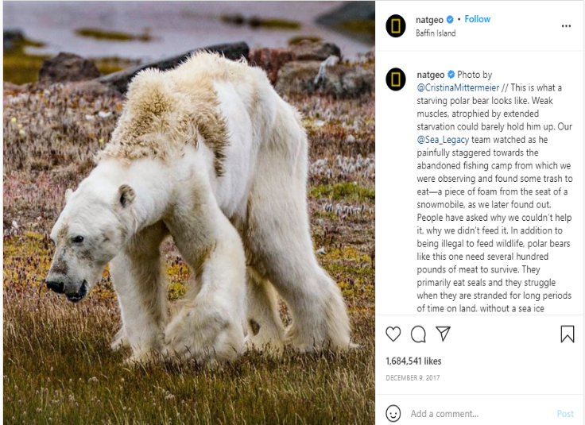

In 2017 NatGeo shared an image of a starving polar bear which highlighted the effect of climate change on wildlife. The post got a big attention which got thousands of likes, and shared by many people, but a like or share on Instagram won’t be helpful to save this animal from starving or the loss of it inhabit, we need to take the right measure to save this animal, so I am looking into do people care about these posts when they see it on social media or they just like and not even try to read and scroll to next post. It never matters how many people liked or shared it, until people take steps to eradicate climate change.

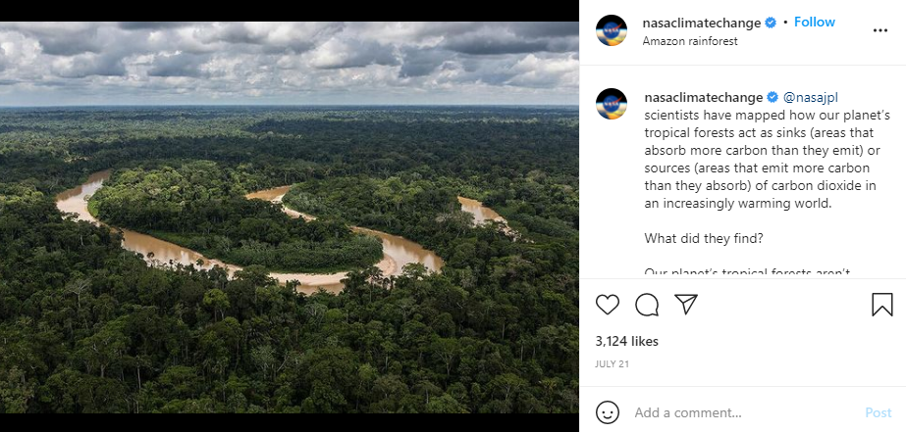

It is not easy for us to understand what is happening in a place where it is hard to reach and see it ourselves, but social media solved that issue, the picture mentioned above is a post shared by an Instagram page, nasaclimatechange. It shows the current face of the Amazon rainforest which is considered as the “Lungs of the Earth”. Through sharing the picture on social media scientists make sure that everyone should be aware of what is happening around the world due to climate change and how it’s affecting our ecosystem, after posting this picture the comment section was filled with people mentioning how humans are going to wipe out this planet and how should the government give priority to climate change and encourage people to take steps to eradicate the effects of climate change. So, I think through sharing this one post can make a difference even a small difference can pave way for a big change.

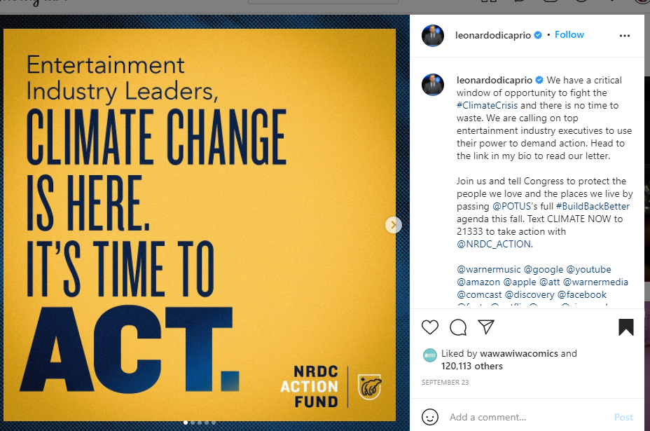

This image is a post shared by the actor and the current environmental activist Leonardo DiCaprio, the post says “Entertainment Industry leaders, climate change is here it’s time to act”. People are tending to follow actors, and other influential people on social media, their stories and posts have thousands of viewers than an ordinary person. Around 50m people follow Leonardo DiCaprio on Instagram and if he shares a post not less than 10m people will read and share his post, but think about if an ordinary person shares a post about climate change, it won’t get that much attention. When Leonardo DiCaprio shared a post about climate change his followers will repost them, but among how many people care about climate change or how many of them want to make the world a better place.

**Discussion**

The pictures I mentioned above are some of the posts shared and liked by thousands of people. When I go through the posts, I understood that they played a major role among the people to make them aware of the climate change issue. When we go through the posts, we can see that all the posts are about the issue of climate change, the first three posts are about the after effect of climate change, especially how it is affecting our ecosystem and its inhabitants. The last post is an awareness post shared by one of the top influencers, the post talks about that climate change is real and it’s time to act, under the post DiCaprio also mentioned some of the ways we can begin to start protecting our planet and to join them. Social media is considered a great tool for effective communication among people, it helps to connect people worldwide, when Greta Thunberg started a protest many people from around the world got inspired by the post shared by millions of people around the world through different social media. There are hundreds of pages and groups in social media related to the environment and our planet and they share posts and videos on an everyday basis, but how many of us care about the posts, majority of us do not even try to read the post, we just scroll away to some fun videos or pictures, some people just look through the post and they will post comments and share it to their story, but do they take any initiative to reduce the climate change effect, this is the question come to my mind when I go through all these data, because I do follow some of these popular pages, but I never put any effort to read them or take a step to save our planet.

From all the articles and posts I collected to find an answer for my research question, I find that social media is a powerful tool for communication. There are lots of campaigns and movements started in social media which created a big change in society. Social media is also used in coordinating rescue and relief operations after climate change-related disasters and to organize movements and campaigns about climate change. David Attenborough’s Blue Planet 2 is a great illustration of how social media can be utilized to reinforce and spread current facts of climate change. Blue Planet 2 focused on our oceans, which speaks about the huge issue of ocean plastic waste. Blue Planet 2 was broadcast on television in late 2017, but the conversation about the series continues social media to this day especially on Twitter. Ultimately it seems that social media can be an incredibly effective tool for communicating about climate change. That’s especially true if we’re focusing on community building and bringing like-minded people together. Social media is also used in coordinating rescue and relief operations after climate change-related disasters and to organize movements and campaigns about climate change. Online protests like #MeToo and #BreakFreeFromPlastc, powered by social media, have grown from powerful online campaigns to real-world policy change. A group called LAD bible created a social media campaign to engage the youth audience, to shift their thinking around climate change, and turn apathy into action. This group used Facebook live to depict the amount of carbon emission released in real-time instigating discussion within the community. This Facebook live resulted in 45 million reach and 8 million engagements, which clearly shows that social media can be used as a tool for awareness about social issues.

Works cited

* National Geographic (@NatGeo). Photo of starving polar bear. Instagram, photographed by Cristina Mittermeier, December 10 2017, https://www.instagram.com/p/BceylHujELW/.
* Nasa climate change (@nasaclimatechange). Photo of tropical forest sinking. Instagram, photographed by nasajpl, July 21, https://www.instagram.com/nasaclimatechange/.
* DiCaprio, Leonardo (@leonardodicarpio), we have a critical window, Instagram, September 23, www.instagram.com/p/CULA5_opeMw/.
* National Geographic Society. “Climate Change.” *National Geographic Society*, 27 Mar. 2019, https://www.nationalgeographic.org/encyclopedia/climate-change/. Accessed date November 16, 2021
* Whiting, Tabitha. “Can Social Media Save Our Planet from Climate Change?” *Medium*, The Startup, 25 June 2019, [https://medium.com/swlh/can-social-media-save-our-planet-from-climate-change-b3b1e81f64f7.](https://medium.com/swlh/can-social-media-save-our-planet-from-climate-change-b3b1e81f64f7.%20%20) Accessed November 14, 2021.
* Limited, Jamaica Observer. “Use Social Media to Combat Climate Change Awareness.” *Jamaica Observer*, https://www.jamaicaobserver.com/opinion/use-social-media-to-combat-climate-change-awareness_147648?profile=1096. Accessed date November 15, 2021.