Shermin Thomas

Professor Marissa Dubois

Major Assignment 3: The Data Report

11/8/2021

**Introduction**

Climate change has been ranked one of the most ubiquitous issues in the world. The weather conditions prevailing in an area over a long period is the climate of that region. Decades ago, a change in the climate pattern was identified globally. This climate change has resulted in the devastation of natural habitats and the decline of various sectors. Nowadays people are very concerned about this issue and there are many ongoing awareness programs and organizations that work around the world for the climate change issue. Starting in the early 2000s social media has had a strong presence in modern society. Nowadays almost everyone has access to a profile on one social media website or another and they are using it to make changes where they see that it needs to be made. There are many pages and groups on social media which deal with environmental issues, they share posts on an everyday basis to make us aware of how to save the planet. I collected my primary data through social media pages like Earth League International, World Conservation Congress, Stand Earth, COP26, and UN Climate Change, also referring to some influencers like Leonardo DiCaprio, who is one of the most prominent climate activists today and the 18-year-old environmental activist girl Greta. My research question is, how does sharing posts, flyers, advertisements, and posters build a vital awareness of climate issues among the people, and does it motivate an ordinary person to take a step to reduce the effect of climate change because it seems that social media is an absolute good tool, which can use for environmental activism and people can share awareness posts through social media. Other than sharing posts using hashtags in a post is one of the popular methods used to ensure that our messages reach a border extensive. Environmental brands have begun campaigning to bring awareness to topics: #FridaysForFuture is one of them. In August 2018 a 15-year-old girl Greta and other environmental activists protested in front of the Swedish parliament for three weeks, they were attempting to bring issues to light against the Swedish government’s absence of activity against climate change and the protest went viral through Twitter and Instagram. This movement shows that through social media people can make a positive difference in the world. The screenshots I mentioned below are some of the posts shared on Instagram by different influential pages and influencers, which were reshared by thousands of people and pages.

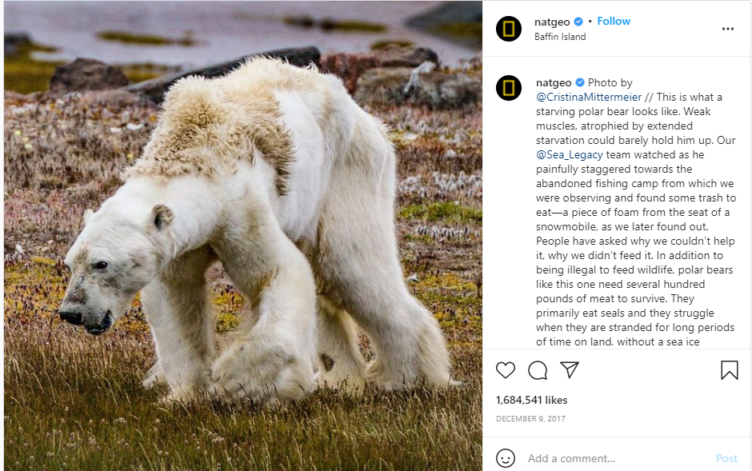**Present Key Data**

This image is a post shared by NatGeo in 2017 of a starving polar bear that highlighted the effect of climate change on wildlife. Due to the absence of ice and snow, this polar bear is in an extremely emaciated state and will likely not live much longer. This post has been liked roughly 1.7 million times on Instagram, but a like or share on Instagram won’t be helpful to save this animal from starving or the loss of it inhabit, we need to take the right measure to save this animal, so I am looking into do people care about these posts when they see it on social media or they just like and not even try to read and scroll to next post. It never matters how many people liked or shared it, until people take steps to eradicate climate change.

Apart from making connections with people, social media is widely used as a key tool to start awareness or protest about issues. Through sharing posts and posting stories social media help people to understand about some on-going issues in the world. Usually, it seems that people are not interested in reading news or watching the news on TV, so social media is considered the easiest way to reach people around the world. The picture posted above is a post viewed, liked, and shared by thousands of people, what if instead of posting on Instagram this picture shared through a new paper or any other news article, it won’t get much attention because a study proves that about 70% of people use social media every day, on the other hand only 29% of people read a newspaper on an everyday basis, all these findings prove that social media is a great tool when something needs real attention.

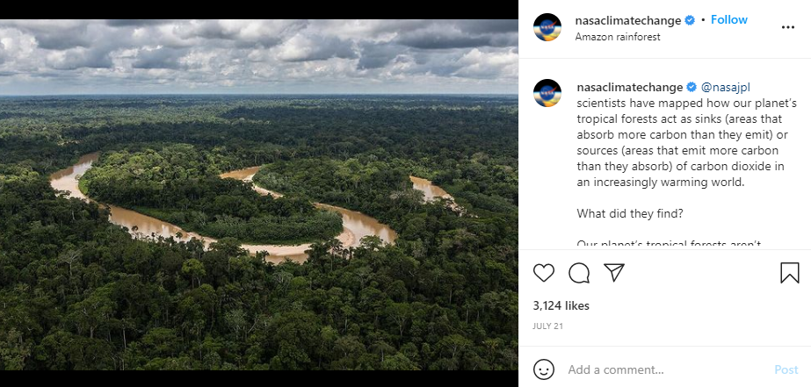

This image is a post shared by nasaclimatechange, the post open our eyes to the current situation of Amazon Forest, a study proves that a part of the Amazon rainforest is now emitting more carbon dioxide than they absorb, raising fears of the potentially devastating impact on its fragile ecosystem and a further worsening of the climate crisis, according to a new study. Amazon is one of the largest rainforests and home to countless species of fauna and flora. But in the past 40 to 50 years, the rainforest has undergone tremendous and disruptive change due to human impact. It has lost 17% of its forest, most of which has been turned into agricultural land for farming and livestock. This led to the rise of temperature and water evaporation to drop, meaning less rainfall.

It is not easy for us to understand what is happening in a place where it is hard to reach and see it ourselves, but social media solved that issue, the picture mentioned above is a post shared by an Instagram page, nasaclimatechange. It shows the current face of the Amazon rainforest which is considered as the “Lungs of the Earth”. Through sharing the picture on social media scientists make sure that everyone should be aware of what is happening around the world due to climate change and how it’s affecting our ecosystem, after posting this picture the comment section was filled with people mentioning how humans are going to wipe out this planet and how should the government give priority to climate change and encourage people to take steps to eradicate the effects of climate change. So, I think through sharing this one post can make a difference even a small difference can pave way for a big change.

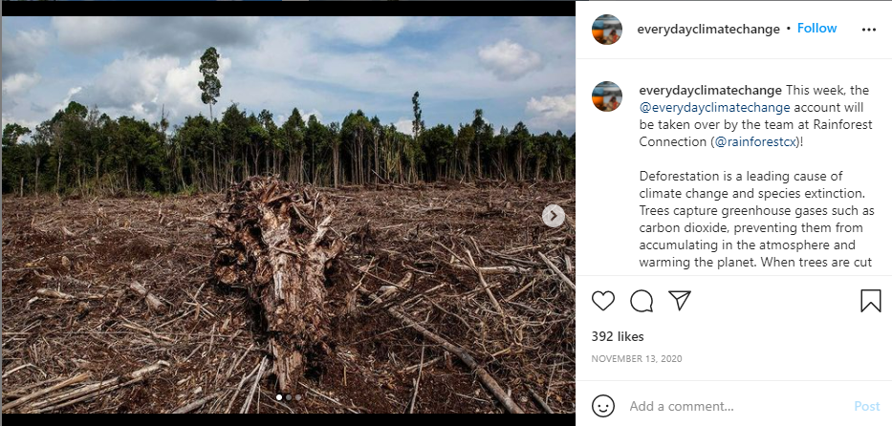

This image is a post shared by the Instagram page, everydayclimatechange. The post portraits deforestation, which is the leading cause of climate change and the extinction of species. The image is shared with a caption explaining the aftermath of deforestation and the major role of trees to balance the ecosystem. Everydayclimatechange is a social media page managed by a diverse group of photographers from 6 continents, they share pictures, posters, and videos related to climate change which make people aware that climate change is real and we have to take steps to reduce the effect of climate change.

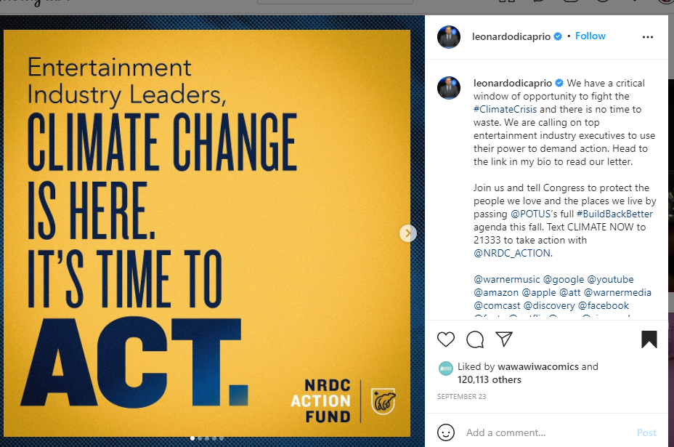 This image is a post shared by the actor and the current environmental activist Leonardo DiCaprio, the post says “Entertainment Industry leaders, climate change is here it’s time to act”. People are tending to follow actors, and other influential people on social media, their stories and posts have thousands of viewers than an ordinary person. Around 50m people follow Leonardo DiCaprio on Instagram and if he shares a post not less than 10m people will read and share his post, but think about if an ordinary person shares a post about climate change, it won’t get that much attention. When Leonardo DiCaprio shared a post about climate change his followers will repost them, but among how many people care about climate change or how many of them want to make the world a better place.

Analysis of Primary Data

My research question is, how does sharing posts, flyers, advertisements, and posters build a vital awareness of climate issues among the people, and does it motivate an ordinary person to take a step to reduce the effect of climate change. To collect my primary data, I gathered some screenshots of the posts shared on different social media pages which talk about climate change, this data helped to build support for my research question. The pictures I mentioned above are some of the posts shared and liked by thousands of people. When I go through the posts, I understood that they played a major role among the people to make them aware of the climate change issue. When we go through the posts, we can see that all the posts are about the issue of climate change, the first three posts are about the after effect of climate change, especially how it is affecting our ecosystem and its inhabitants. The last post is an awareness post shared by one of the top influencers, the post talks about that climate change is real and it’s time to act, under the post DiCaprio also mentioned some of the ways we can begin to start protecting our planet and to join them. Social media is considered a great tool for effective communication among people, it helps to connect people worldwide, when Greta Thunberg started a protest many people from around the world got inspired by the post shared by millions of people around the world through different social media. There are hundreds of pages and groups in social media related to the environment and our planet and they share posts and videos on an everyday basis, but how many of us care about the posts, majority of us do not even try to read the post, we just scroll away to some fun videos or pictures, some people just look through the post and they will post comments and share it to their story, but do they take any initiative to reduce the climate change effect, this is the question come to my mind when I go through all these data, because I do follow some of these popular pages, but I never put any effort to read them or take a step to save our planet.

**Works Cited**

* National Geographic (@NatGeo). Photo of starving polar bear. Instagram, photographed by Cristina Mittermeier, December 10 2017, https://www.instagram.com/p/BceylHujELW/.
* Nasa climate change (@nasaclimatechange). Photo of tropical forest sinking. Instagram, photographed by nasajpl, July 21, https://www.instagram.com/nasaclimatechange/.
* Everyday climate change (@everydayclimatechange). Photo of deforestation. Instagram, photographed by rainforestcx, November 13 2020, https://www.instagram.com/everydayclimatechange/.
* DiCaprio, Leonardo (@leonardodicarpio), we have a critical window, Instagram, September 23, www.instagram.com/p/CULA5_opeMw/.
* National Geographic Society. “Climate Change.” *National Geographic Society*, 27 Mar. 2019, https://www.nationalgeographic.org/encyclopedia/climate-change/. Accessed date November 7, 2021
* Whiting, Tabitha. “Can Social Media Save Our Planet from Climate Change?” *Medium*, The Startup, 25 June 2019, [https://medium.com/swlh/can-social-media-save-our-planet-from-climate-change-b3b1e81f64f7.](https://medium.com/swlh/can-social-media-save-our-planet-from-climate-change-b3b1e81f64f7.%20%20) Accessed November 5, 2021.